SENIOR INFORMATION
FOR FSA ID & FAFSA

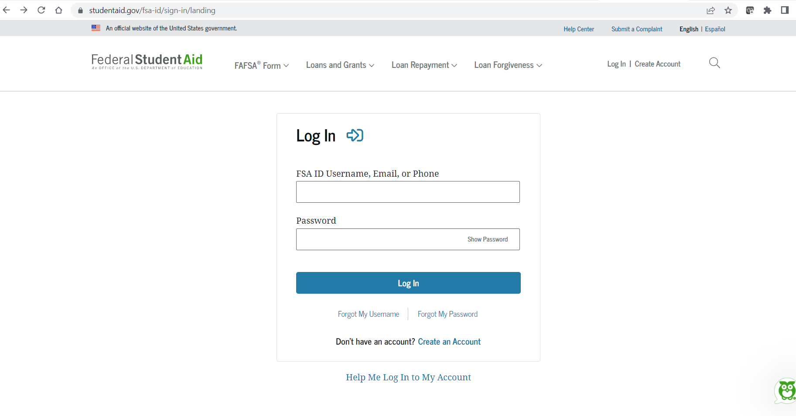

FSA ID
- https://studentaid.gov/fsa-id/sign-in/landing
- FSA ID will be your email address, and password
- Both a parent and the student must have an FSA ID to start the FAFSA process.
- You will need to do get your FSA ID and should do that NOW! The FSA ID will allow you to electronically “sign” your FAFSA application. It verifies your social security number and your name with the Social Security Administration.
- Supply an email address that is active for both the parent and student. The emails cannot be the same for the parent and adult. They must be separate emails. STUDENTS- DO NOT USE YOUR SCHOOL EMAIL! It will be deleted after you graduated.
- If the parent already has a child in college, the parent will use the same FSA ID. If a younger sibling is going to college, the student will need to get an FSA ID. The FAFSA will need to be completed each year the student is in college and use the same FSA ID. Write your FSA ID down somewhere safe for future use.
  - To create a new FSA ID, click the tab in the middle of the webpage that says create an FSA ID. Complete the process and remember the answers to the questions that you set up.
  - The verification process can take up to three days. An email will be received to the email address provided confirming the ID and the FAFSA process can them be started.

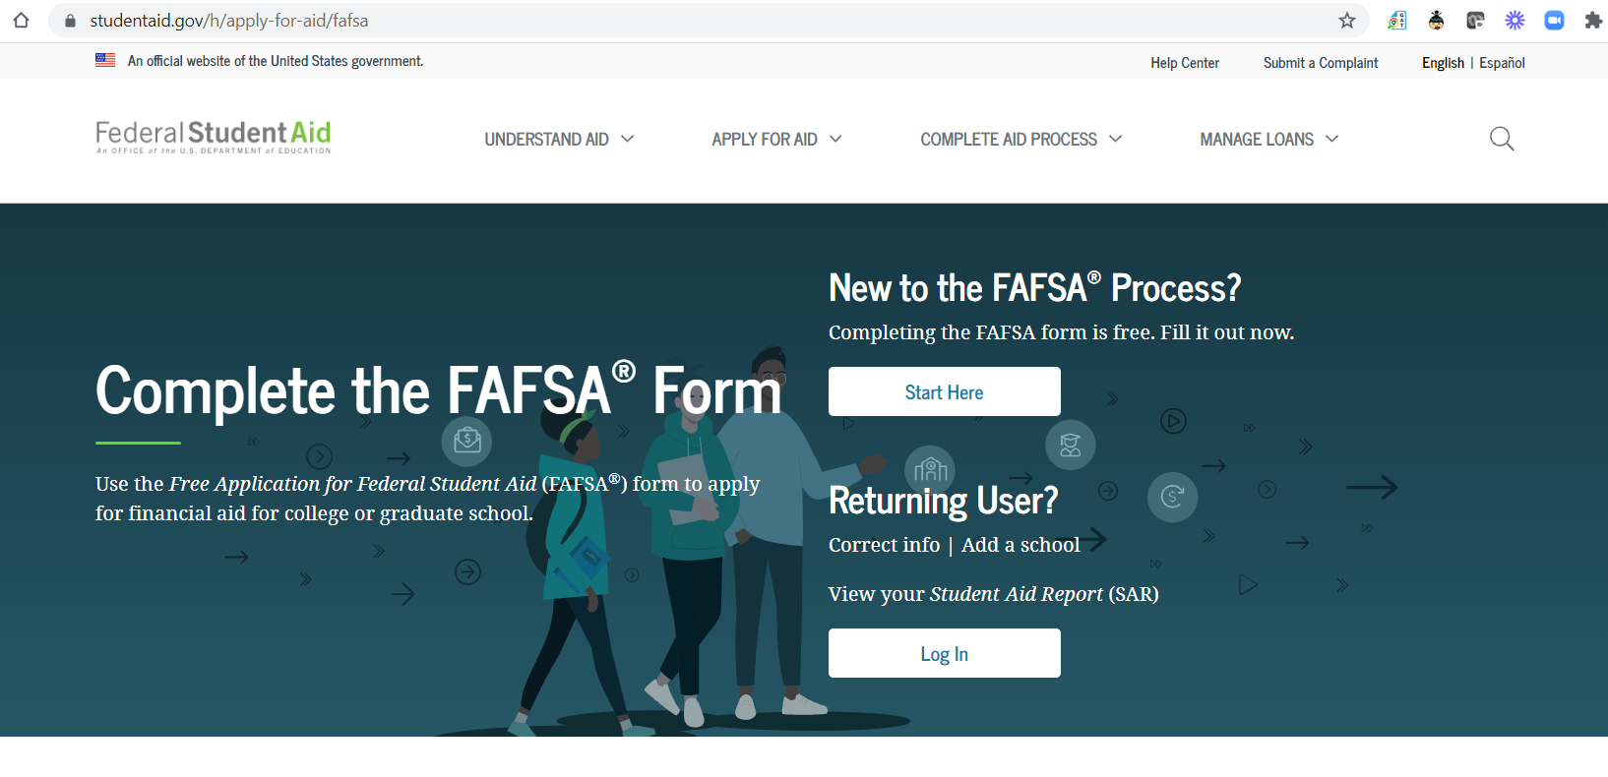

FAFSA
Free Assistance for Student Aid
- https://fafsa.ed.gov/
- The FAFSA opens every year on October 1st. Check with the colleges your child is attending to find the due dates for the FAFSA. (Most Missouri schools have a Feb 1 deadline, but some are as early as Dec 1.)
- Complete the FAFSA for the Class of 2023. You will complete the 2023-2024 FAFSA using 2021 tax information
- When applying for the FAFSA, make sure you are entering the correct information for the correct person. This is a common mistake, just double check before you put any information in.
- You will have the option to use the IRS Upload to input your 2021 tax information. The Upload allows for information to be uploaded and reduces the chance for any errors.
- An explanation of the information needed is provided, just click on the question mark next to the question.
- Submit your FAFSA to all colleges you are interested in attending.
- Once all the needed information is in the FAFSA application, you will be asked to “sign” the FAFSA with you FSA ID. (email or login, and password)
- Monitor your email- if additional information is need you will be notified.
- You will receive your Award Offer through the colleges; you do not have to accept all financial aid offered (loans).

