SENIOR INFORMATION
FOR FSA ID & FAFSA

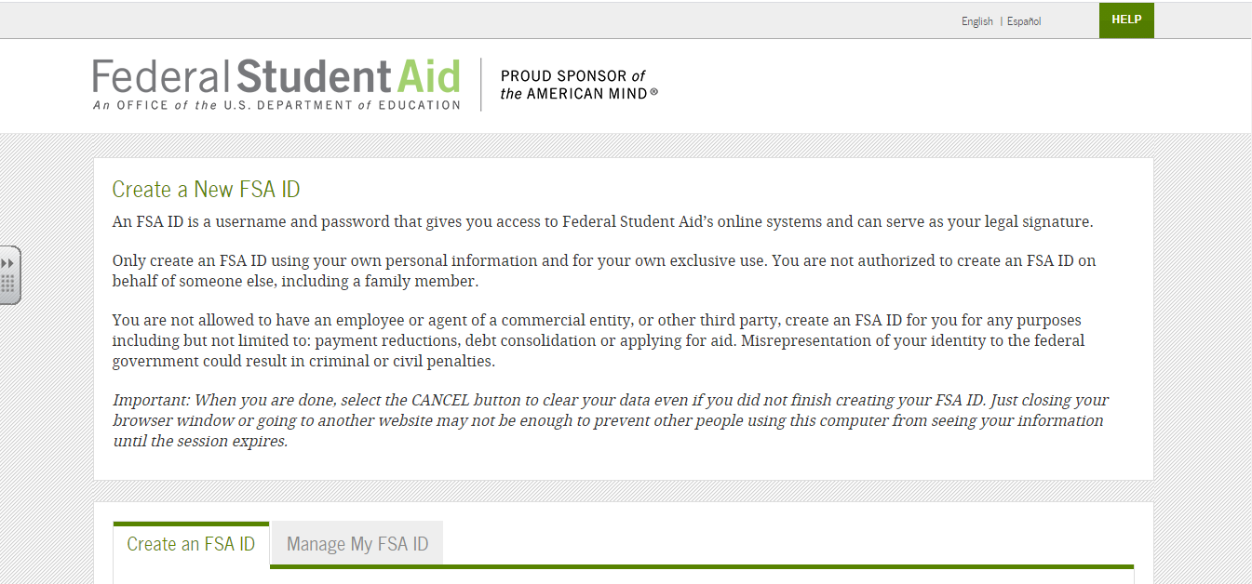
FSA ID
- https://fsaid.ed.gov/npas/index.htm
- Both a parent and the student must have an FSA ID to start the FAFSA process.
- You will need to do get your FSA ID and should do that NOW! FSA ID will allow you to electronically sign your FAFSA application. It verifies your social security number and your name with the Social Security Administration.
- Supply an email address that is active for both the parent and student. The emails cannot be the same for the parent and adult. They must be separate emails. STUDENTS- DO NOT USE YOUR SCHOOL EMAIL!
- If the parent already has a student already in college, the parent will use the same ID. However if there is a new student going into college, the student will need to get their own. One parent and the student must get a FSA ID. The FAFSA will need to completed t each year the student is in college and use the same FSA ID. Write your FSA ID down somewhere safe for future use.
- To create a new FSA ID, click the tab in the middle of the webpage that says create an FSI ID. Complete the process and remember the answers to the questions that you set up.
- The verification process can take up to three days. An email will be received to the email address provided confirming the ID and the FAFSA process can them be started.

FAFSA (Free Assistance for Student Aid)
- Below is the link and a picture of the webpage.
- https://fafsa.ed.gov/

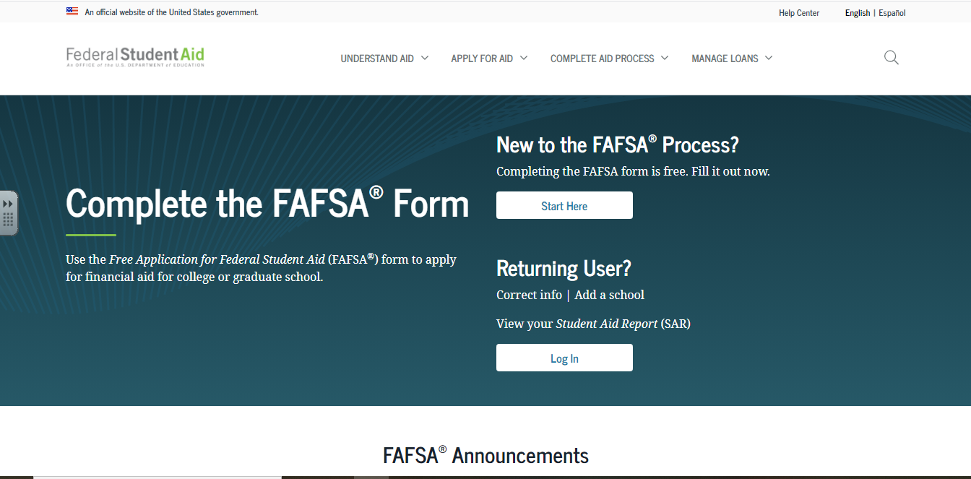

FAFSA
Free Assistance for Student Aid
- Can start application process October 1st. Check with the colleges your child is attending to find the due dates for the FAFSA. (Most Missouri schools have a Feb 1 deadline but some are as early as Dec 1.)
- Complete the FAFSA for the 2021-2022 School Year.
- When applying for the FAFSA, make sure you are entering the correct information for the correct person. There will be a tab on the left hand side that will say student, parent1, or parent2. This is a common mistake, just double check before you put any information in.
- You will have the option to using the IRS Upload to input your 2019 tax information. Each year you will upload two year old data. The Upload allows for information to be uploaded and reduces the chance for any errors.
- An explanation of the information needed is provided, just click on the question mark next to the question.
- Once all the needed information is in the FAFSA application, you will be asked to “sign” the FAFSA with you FSA ID.
- Monitor your email, if additional information is need you will be notified.
- You will receive your Award Letter through the colleges; you do not have to accept all financial aid given (loans).

